**Surfers Against Sewage – Our work in 2017**

**2017 in numbers**

**1,393** – Beach cleans organised

**135** – Regional environmental volunteers

**132** – Plastic Free Community Leaders

**34,779** – Beach clean volunteers

**127,000** – Volunteer hours contributed worth approximately **£1,126,260**

**97.2** – Tonnes of plastic pollution removed from our beaches

**29,108 –** Single use plastic bottles recycled

**132** Schools visited – **12,179** pupils spoken to

**21** – Members of Parliament as part of our All-Party Parliamentary Group

**291,485 –** People have signed our petition calling for a single use bottle deposit scheme

**91 -** Communities working towards going Plastic Free – **Penzance already there!**

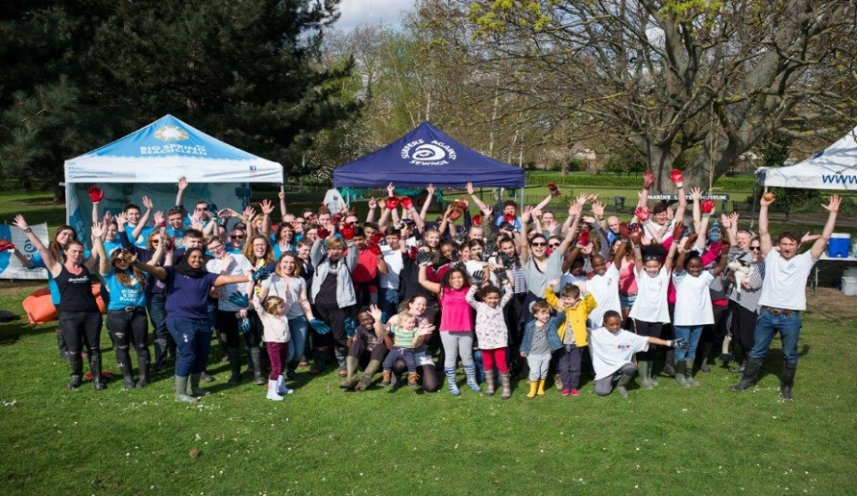

We’ve had an amazing year of beach cleans, organising 1393, nearly 4 every day of the year! This has been made possible by an amazing 34,779 volunteers who together have removed nearly 100 tonnes of marine litter from the UK’s beaches.

**Regional Environmental Volunteers**

We now have an amazing **135 Regional Environmental Volunteers**. This means that we cover 135 coastal locations throughout the UK. We have held 3 training events for our volunteers in 2017 meaning that every one of them has attended at least 1 training event.

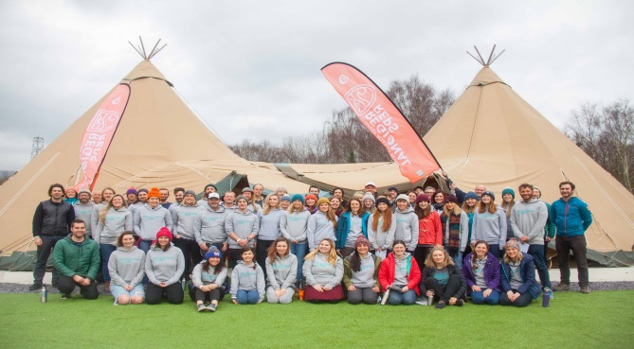

**Volunteer Stats**

**135** – Coastal locations in the UK covered

**388** – Beach cleans organised

**461** – Environmental education talks delivered

**10,992** – Local community volunteers recruited

**3 –** Training events held for our volunteers

**Our Education Work**

We’ve significantly increased the amount, range and sophistication of our education work in 2017. Through our education programmes we aim to equip, empower and inspire the next generation of ocean and inland conservationists. We now have 4 different programmes to work with a variety of different school groups, these include:

**The SAS education team has**

Visited 132 schools

Spoken to 12,179 pupils

Distributed 60 Plastic Free School Packs

Inspired the creation of 20 school “Anti-Litter Action” Plans

* **Be the Change**
* **Seas 4 Life**
* **Plastic Free Schools**
* **Ocean School**

**Our Be The Change** education programme has seen us visit North Devon, Birmingham, Newcastle & Bristol. It’s been great to take our education talks inland to urban areas and the kids have been incredibly engaged.

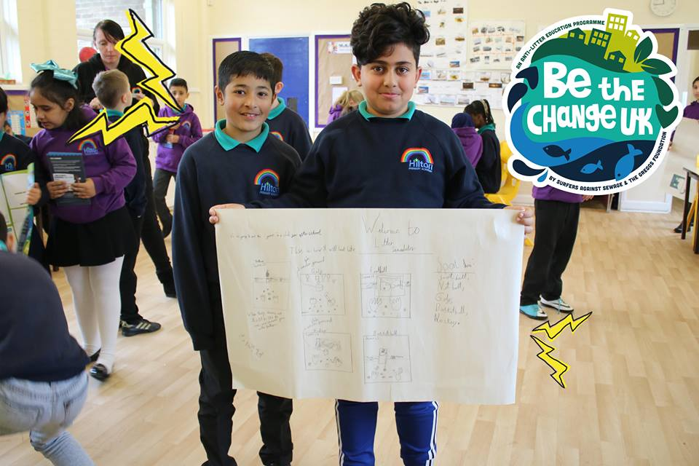 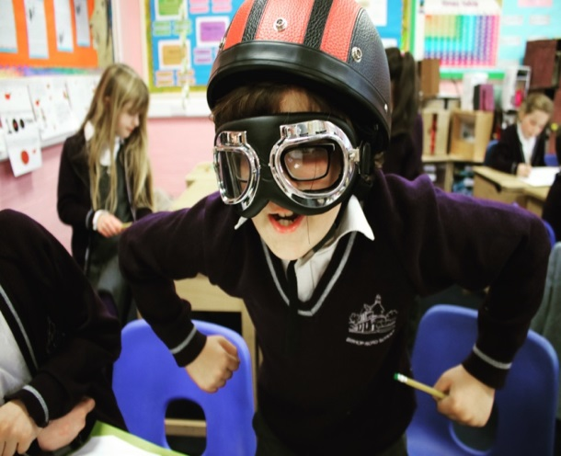

**Ocean Schools** enabled us to provide outdoor educational experiences to **over 1,300 pupils** in the summer of 2017. Not everyone is lucky enough to know how amazing our beaches, waves and marine ecosystems are, sharing this beauty with children across the South West is vital to inspire and equip the next generation to become ocean guardians.

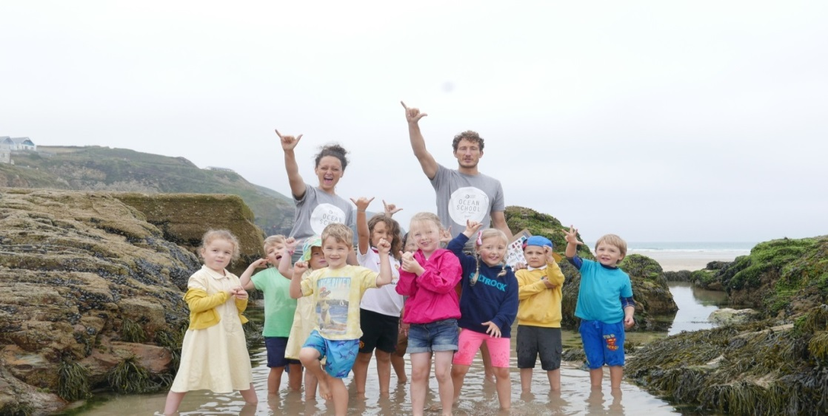

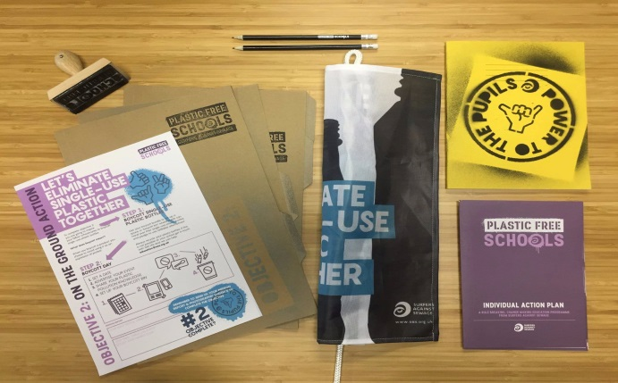

**Plastic Free Schools –** is a pupil led education programme designed by SAS to create real positive environmental change in UK schools and beyond!

**So far we have distributed 60 packs to schools in the UK, and have had a further 90 schools request packs!**

**Teacher Feedback**

*“Thank You for today. The Children have been really inspired and you have had a real impact on them.”* **Claire Blackford, Teacher, Bishop Road Primary School**

*“Thornton children have been really inspired and have had their eyes-opened to the severity of littering – as well as the positive impact we can all have on improving the situation.”* **Krisha Ghandi, Year 5 Teacher, Thornton Primary School**

**Student feedback**

*“I liked the fact that we were involved in the conversations rather than just being talked to”* **Leah**

*“I liked when we found out the facts about how long crisp packets/plastic bottles take to break down (the really old crisp packet!)”***Reece**

*“I liked the part in the conversations where we found out about the damage done to the environment by litter – I think it will stop most of us dropping litter”* **Callum**

**Our Beach Clean Box & Schools Beach Clean Box**

Our Beach Clean Boxes have been a huge success helping communities across the UK to organise 417 beach cleans. They have proved especially useful for our volunteers to take along to events. They have proven so popular that we have recently launched a dedicated **Schools Beach Clean Box!**

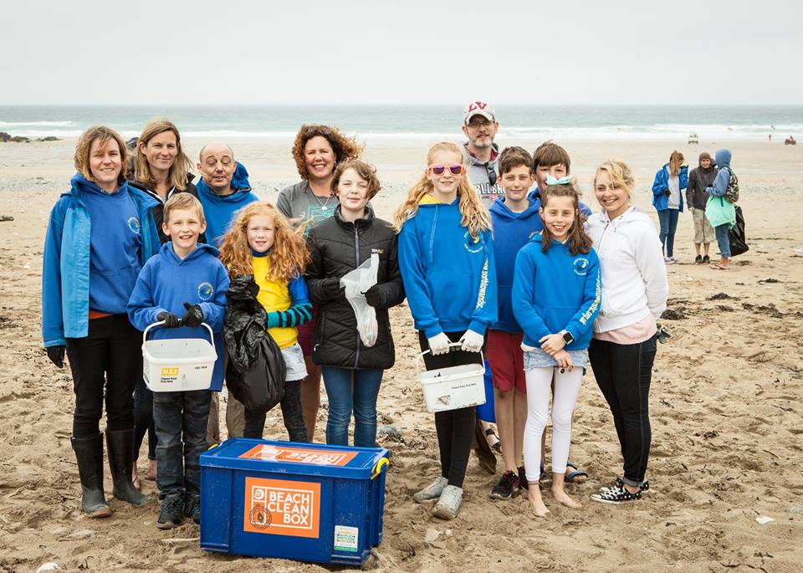 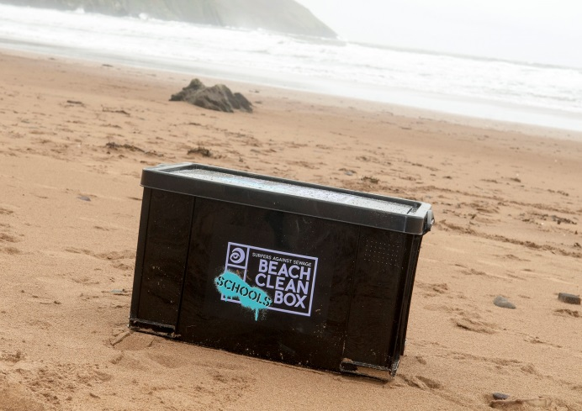

**Plastic Free Coastlines**

Our Plastic Free Coastline project was launched on 20th July 2017 and has already had a huge impact. The idea is for communities to work with local government and businesses to become plastic free and stop plastic pollution at source, once this has been achieved we award them Plastic Free Status.

**1 –** Plastic Free Community Approved – **Penzance**

**91 –** Communities working towards Plastic Free Accreditation

**132 –** Plastic Free Community Leaders

**11,500 –** Individuals have downloaded our Plastic Free Toolkit

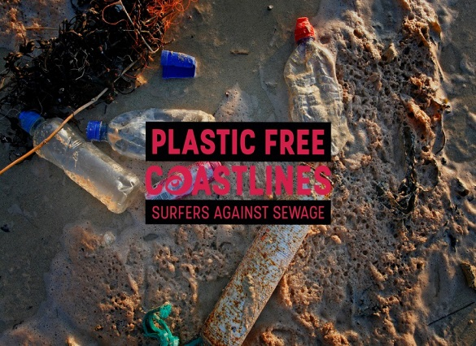

**Michael Gove MP (Secretary of State for the Environment)**

*“It is campaigns like this, and environmental organisations like Surfers Against Sewage and its awarding of Plastic Free Coastline status, that spread an idealism and commitment to halt and reverse the trends and forces harming our planet. They show us that where there’s a will there’s a way to improve the environment for the next generation.”*

**Momentum builds for a Deposit Return System (DRS) thanks to our Message In a Bottle Campaign**

In the UK we use a staggering 38.5 million single-use plastic bottles and a further 58 million cans every day. Only half of these are recycled, so it’s no surprise that many of these end up on our beaches and in our oceans.

We have been at the forefront of campaigning for a deposit return system, whereby a small deposit on plastic bottles dramatically increases return and recycling rates. Over the past year **almost 300,000 supporters have signed our petition,** which we delivered to **10 Downing Street** in September. We have also engaged regularly with the **Environment Minister Therese Coffey MP** on the issue, presented oral and written evidence to the **Environmental Audit Committee**, given evidence to the **London Assembly Environment Committee** and provided **Defra** with detailed evidence to their consultation on deposit return systems.

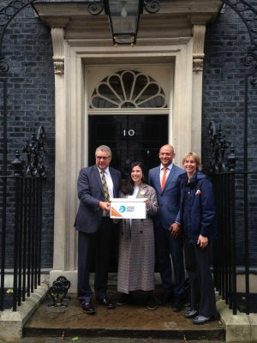 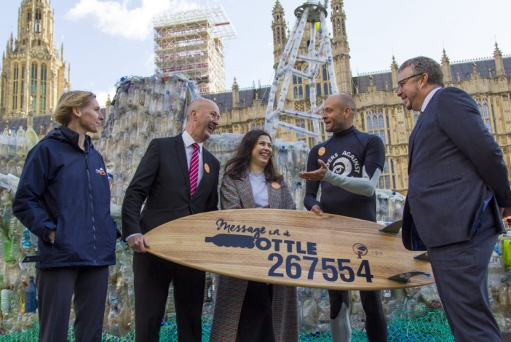

**Environment Minister Therese Coffey MP** spoke at our Plastic Free Coastlines event to update us on the government’s progress towards DRS. She has recently visited Norway to witness successful deposit systems in action as a result of our campaign, which will help inform how the UK can plan & introduce a successful deposit return system. Our petitionhas been one of the driving forces to engage the government, industry and the public on the issue of plastic bottle pollution. We are also delighted that Iceland and the Co-op supermarkets have added their support for deposit returns. We are truly on the cusp of huge change on plastic bottle pollution!

**Surfers Against Sewage – All-Party Parliamentary Group**

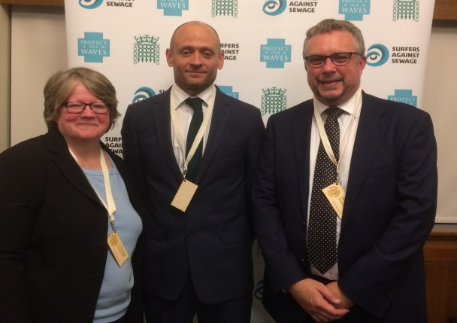

**Our APPG (consisting of 21 MP’s)** continues to provide SAS with an essential platform to raise serious environmental threats and marine conservation campaigns directly with politicians and senior civil servants. It also seeks cross-sectorial solutions to protect our coastal environment from marine litter, water pollution, habitat destruction and more.

In November we were thrilled to welcome and engage government Ministers, Members of Parliament, industry leaders, environmentalists, NGOs and activists at our Plastic Free Coastlines event in Parliament to highlight plastic pollution and the growing support for a UK-wide deposit return system (DRS). It provides a platform for all stakeholders to discuss solutions to the plastic pollution issue.

**Communicating the issues that we are seeking to address**

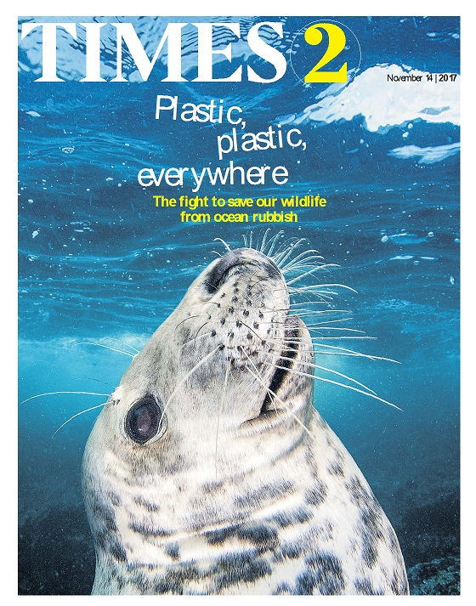

2017 has seen Plastic Pollution come to the forefront of the news agenda and we’ve been delighted to have our work featured in **The Times, The Daily Mail, The Telegraph, The Guardian and hundreds of smaller regional newspapers.** We have also appeared on every major UK TV network. This coverage is helping us to build our community of volunteers, educate people on the issue and persuade all stakeholders to make the changes we need to go plastic free.

**We have been quoted in official Parliamentary business 8 times during 2017.**

We have updated our website in 2017, [www.sas.org.uk](http://www.sas.org.uk) making it easier for people to become engaged with our work.

We now reach nearly 300,000 people through our Social Media networks.

**Water Quality**

Our Safer Seas Service is the only national free real-time water quality app. The app is free to download or to access via an online interactive map. 7 coastal water companies provide free Combined Sewer Overflow (CSO) data during the bathing season, with Wessex Water, Welsh Water, Yorkshire Water and Northumbrian Water providing data year round. The Environment Agency provide simplified Pollution Risk Forecasts at 155 sites across England.

We are currently developing a new phase for the Safer Seas Service to expand reach, usability and function.

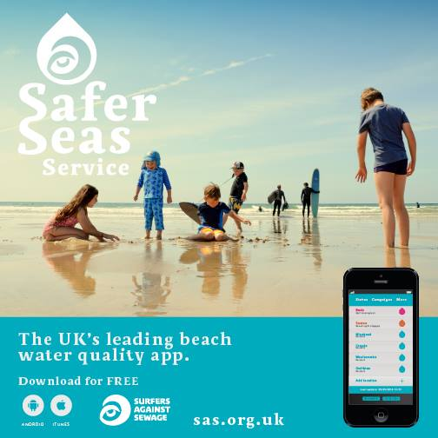

**330** – Beaches covered by our Safer Seas Service App

**20,000** – Registered users

**353,329** – Reduced water quality alerts issued in 2017

**1,605** – CSO alerts

**2,867** – Pollution Risk Forecast warnings issued

**The SAS Team & Governance**

We now have a team of 13 people working at SAS. Ellie our Education Officer has settled in well and has already had a huge impact, helping to develop new schools programmes and reach more students than ever before. In 2018 we are hoping to recruit a Project Officer to work on our Plastic Free Coastlines project.

We are delighted to have 3 new Trustees on our Board.

* Dr Heather Koldewey is a marine biologist and environmentalist. She is currently the Section Head of Global Programmes at the Zoological Society of London.
* Jon Khoo is Innovation Partner at Interface with a focus on sustainability, inclusive business and intrapreneurship.
* Ben Suffell is the founder and managing director of QTS Fundraising. He is also a founding member of The Olive Network, a fledgling online community, designed to engage people across the globe and to curate humanitarianism by encouraging charities, NGO’s and individuals to collaborate.

We are a small team that continues to have a big impact in our area of work thanks to the incredible community of volunteers that we work with. Our philosophy is to give the community the tools, knowledge & passion to protect the marine environment.