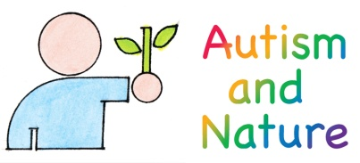
Tel: 01622 632517

Email: david.blakesley@autismandnature.org.uk
www.autismandnature.org.uk
31 October, 2017

Mr R.G.H. Lewis
The Nineveh Charitable Trust
Park Farm
Frittenden Road
Biddenden
Kent TN27 8LG

Dear Mr Lewis

Helping children with autism and related disabilities to learn about and experience the countryside

I am pleased to send you our second Annual Progress Report that summarises our work over the past year and includes an update on our plans for Year 3 of the Nineveh Charitable Trust funded project. I have also enclosed a copy of our guide ‘Visiting the Essex countryside: a guide for parents, carers and teachers of children with autism’ together with a copy of ‘Alex and Rosie’s Adventures in Essex’.

On behalf of Autism and Nature, I would like to thank you very much for the continued support of The Nineveh Charitable Trust. This has enabled us to produce and print three thousand copies of the guide, and two thousand copies of the story book. These are being distributed to families and special schools in Essex by Essex County Council Short Breaks for Disabled Children and Young People. I will also email you a copy of this letter, together with an electronic version of our Annual Progress Report and pdfs of the books. If you are able to put the guide and story book onto your website, we would appreciate that.

I hope that you will be pleased with the progress described in the Report and our plans for the coming year. Thank you once again for funding Autism and Nature’s work, it is very much appreciated.

Yours sincerely

Dr David Blakesley CEnv MCIEEM
Director

